Homework 1: UI Hall of Fame or Shame

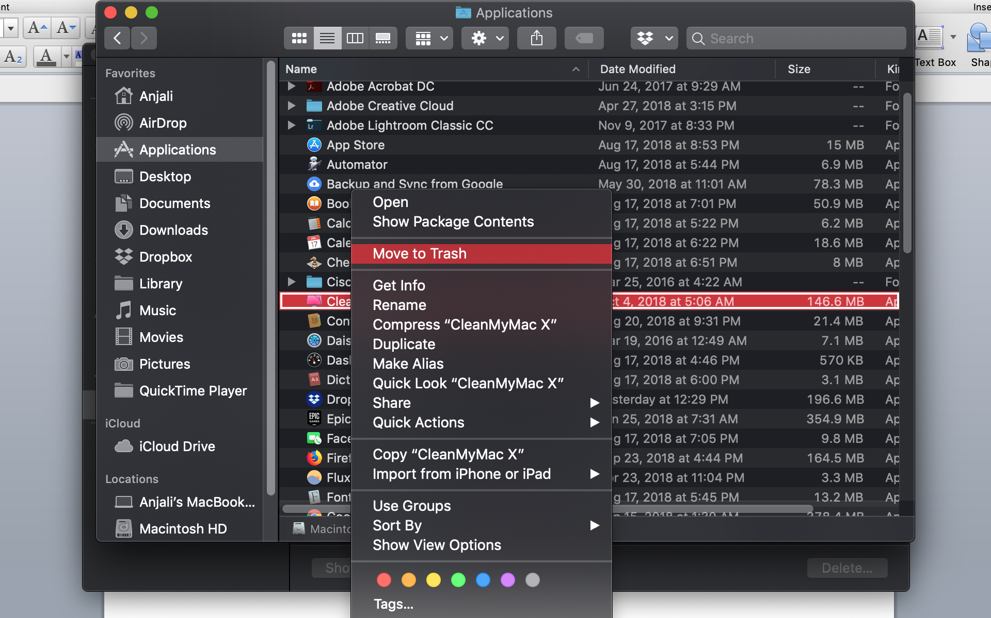

Figure : Trying to move the application to trash

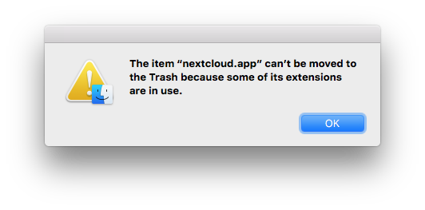

Figure : "nextcloud.app" should be changed to "CleanMyMac X". Error Message received when trying to uninstall.

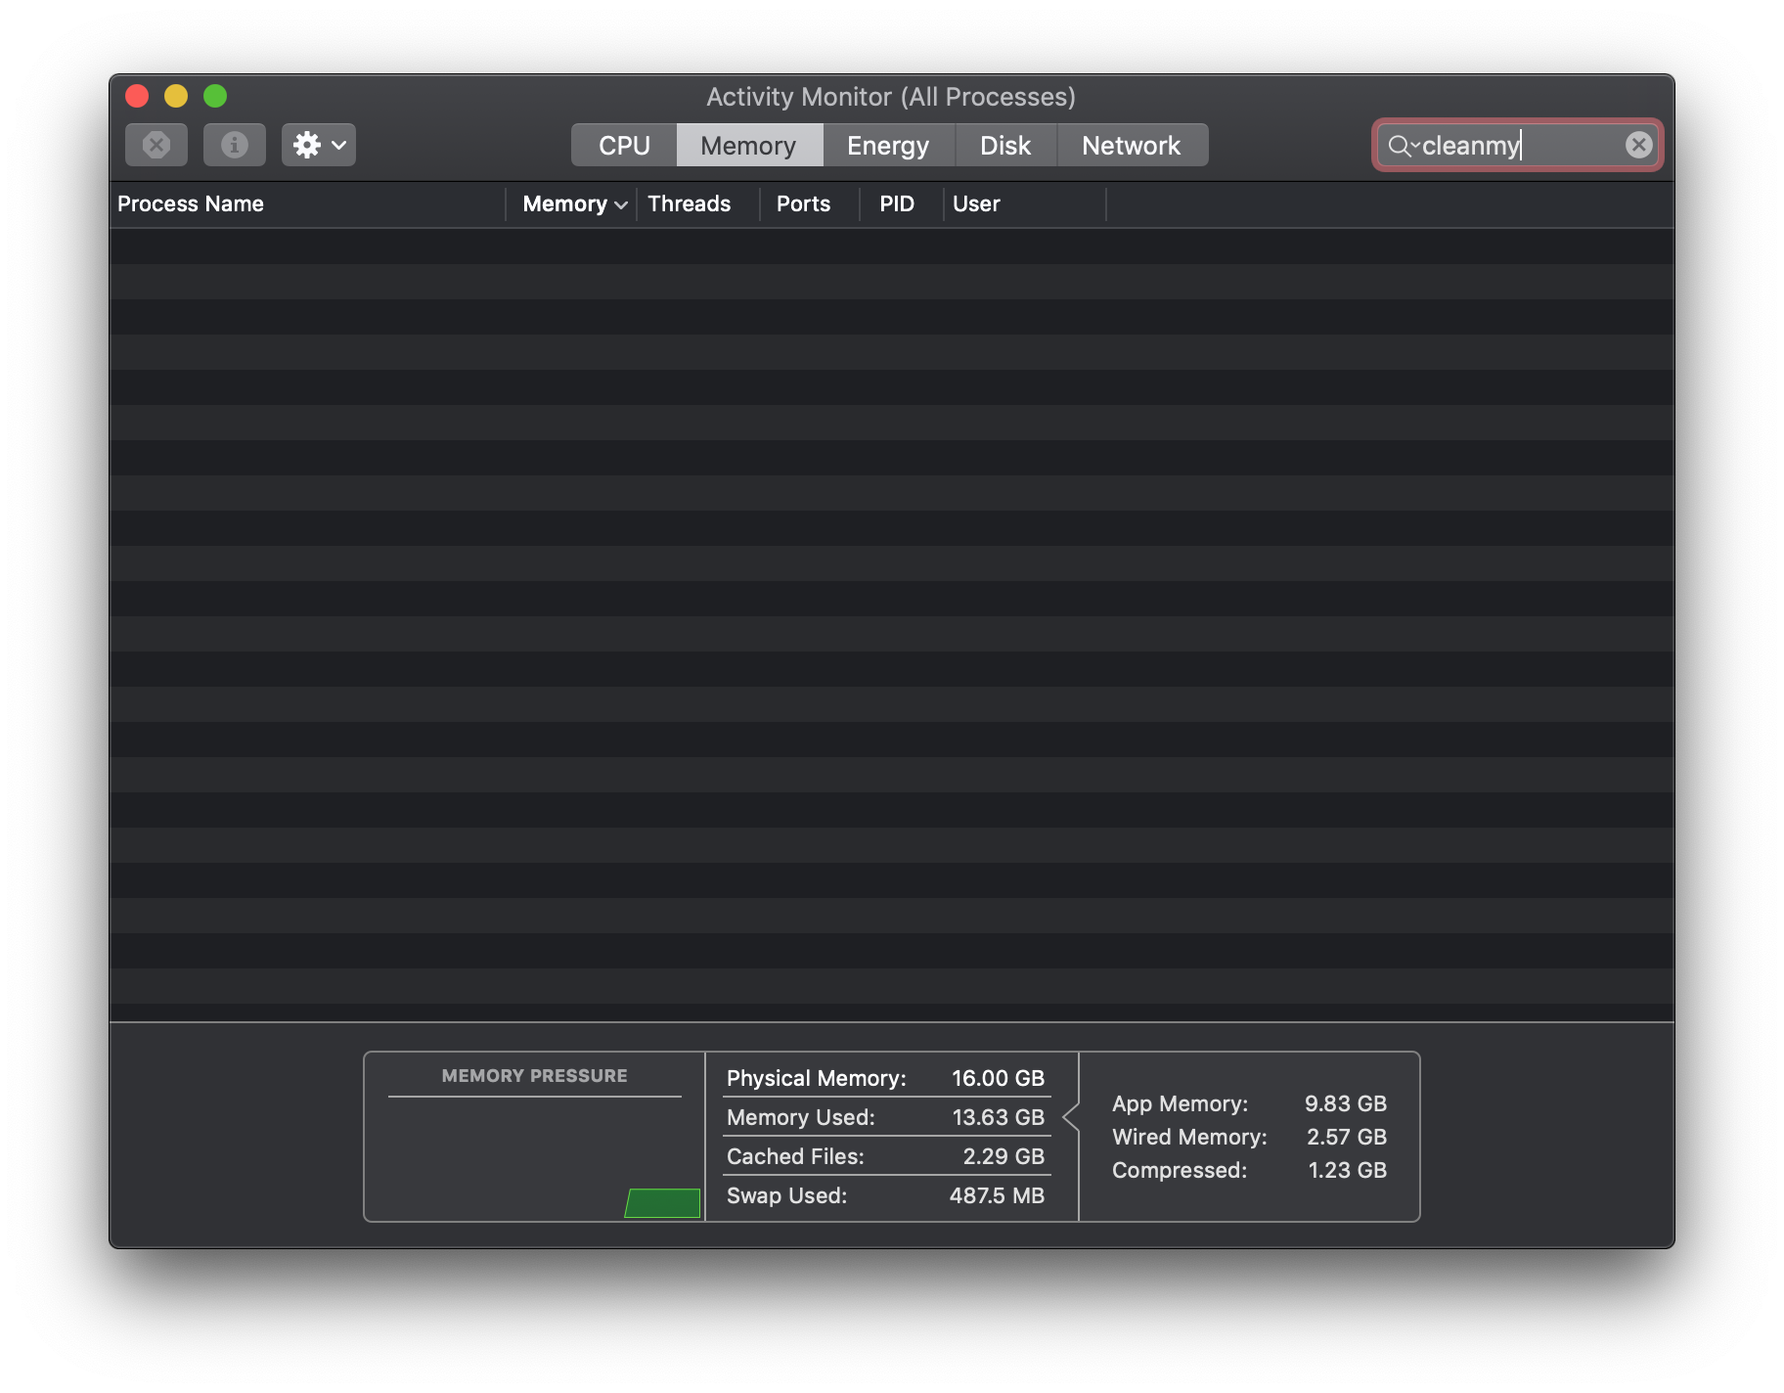

Figure : Activity monitor showing that the application wasn't running. What else should I look at?

* Macbook uninstaller
  + Hall of shame
  + Macbook uninstaller is the built in way to uninstall applications from the disk and gives an error message if something is wrong.
  + This uninstaller can be used on any Apple laptop or desktop.
  + This uninstaller has moderately bad learnability. When the uninstaller gives this error message, it is unclear how to proceed. I went to the activity monitor to try to see if the application was still running but it was not anymore. The error message did not give me any hints on how to fix the issue. To fix the issue I had to google how to fix the issue, and it was still not an intuitive fix. Thus this uninstaller has bad learnability since it does not give information about how to resolve commonly occurring issues. In terms of efficiency, the uninstaller can be invoked by moving multiple applications to the trash at once. This chunking together of the uninstalling shows good efficiency. The uninstaller is somewhat prone to safety errors in the form of inattention. The uninstaller could easily be invoked on the wrong application by dragging a chunk of applications into the trash. There is another message afterwards to permanently uninstall the application though, and so two mistakes have to be made consecutively in order to go through with the safety error.

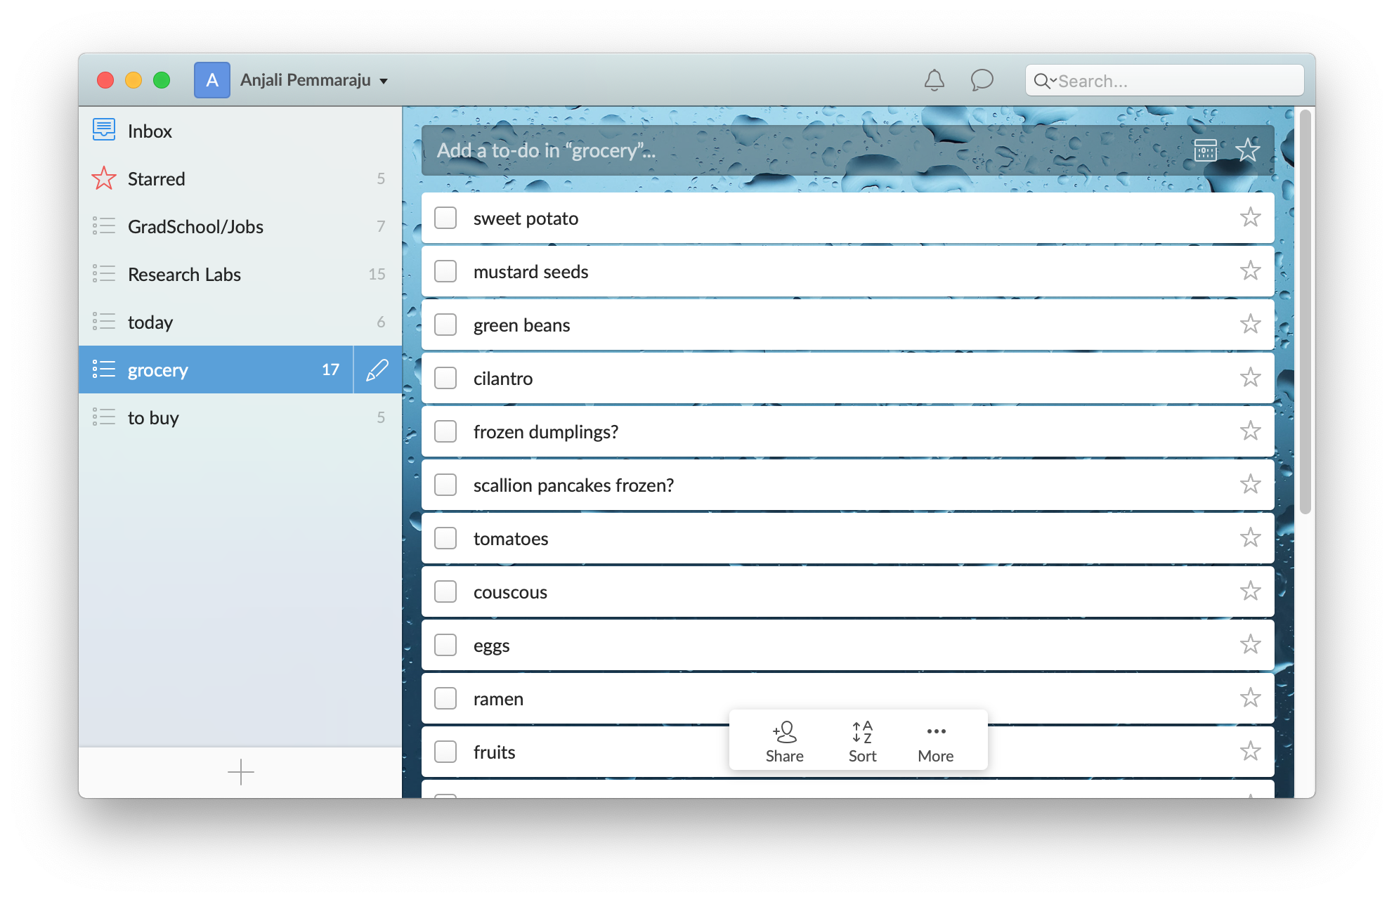

Figure : Example of wunderlist gui

* Wunderlist
  + Hall of Fame
  + This is a list maker, which can be organized by topic and each item can be checked off or starred according to priority.
  + It is a web app and also a desktop app that can be downloaded for free.
  + I have this app downloaded on my computer to use for making lists.
  + This app has good learnability. It is very intuitive to add a list and add items to each list. It is also very easy to “check off” a to-do and “star” one based on the UI, which are things that make sense to most people making a physical list already. In terms of efficiency, it is not easy check off or star multiple to-dos at once so it is not good at chunking. It is also not possible to delete many lists at once, thus there is pretty poor efficiency. However, it is unlikely that anybody needs to star, check off, or delete multiple things at once, thus even though technically the app has poor efficiency it does not really affect the performance. In terms of safety, this app is decently safe. Lists and items can easily be recovered. It is easy to make a mistake to check off the incorrect item though.